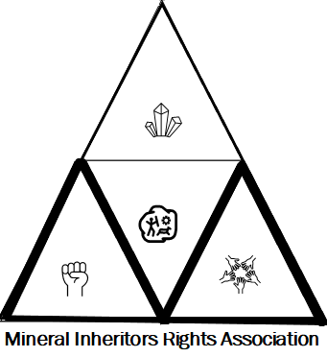 MINERAL INHERITORS RIGHTS ASSOCIATION

PRESS RELEASE
Violation of Pre-Legislative Consultation Policy (2014) and Right to Information Act in the proposed mining reforms

New Delhi, 27th August: The Government of India has brought yet another undemocratic, anti- people announcement proposing mining reforms aligning with the Atma Nirbhar Bharat Scheme for enhancing private investments in the mineral sector. The Ministry of Mines has put up a notice on 24-August-2020 seeking public comments on substantial matters of reform of mineral laws, rules and regulations within a period of 10 days, i.e, 3-Sep-2020.
We are anguished to note that only 10 days have been provided for the proposed mining reforms that is extremely crucial and would have huge implications across the country. What is even more disturbing and dangerous is that the State governments have not yet been consulted and a 10-day period for the States to respond undermines the federal spirit of this nation. This is not even enough time to seek information under the RTI Act to evaluate the proposals meaningfully. We note that this clearly violates the Pre-Legislative Consultation Policy (PLCP) of the Government of India, that mandates a transparent pre-legislative
process that needs to be followed before laws are amended. One of the key decisions in the order states that:
“The Department/Ministry concerned should publish/place in public domain the draft legislation or at least the information that may inter alia include brief justification for such legislation, essential elements of the proposed legislation, its broad financial implications, and an estimated assessment of the impact of such legislation on environment, fundamental rights, lives and livelihoods of the concerned/affected people, etc. Such details may be kept in the public domain for a minimum period of thirty days for being proactively shared with the public in such manner as may be specified by the Department/Ministry concerned”. (Order of the Ministry of Law and Justice notified in 2014)
We would further like to point out that Section 4(1)(c) of the Right to Information Act, 2005 provides that “Every Public Authority shall publish all relevant facts while formulating policies or announcing decisions which affect public”. All the source data, calculations and conclusions should be have been made available to the public prior to asking for comments. In addition, it would have been appropriate to put up the notice in regional languages as well, at a minimum, the languages of the mineral resource-rich states.

The announcement is, thus, a serious infringement of the democratic process and must be challenged. Well-known RTI activist and founder member of Mazdoor Kisan Shakti Sangathan, Nikhil Dey said that "the recent move by the Government of India to amend critical laws governing minerals, in the midst of a pandemic, is deeply disturbing and undemocratic. It not only violates Section 4(1)(c) of the Right to Information Act which mandates that Government must disclose information before taking key policies, it also violates the Pre-Legislative Policy Order issued by the Ministry of Law that sets minimum norms of public consultation that ought to be followed by the Government before amending / passing laws." The government must guarantee a well-informed public consultation to any policy changes and decisions that would impact its citizens. It must ensure that the citizens are given adequate time to register their comments. R.Sreedhar, a geologist and Managing Trustee of Environics Trust commented that, “the government is making a mockery of cooperative federalism and transparency when it seeks responses to far reaching changes in the mining sector in India in 10 days! More appalling is it's dismissive attitude towards the people who will be directly affected.”
We, therefore, appeal to all the concerned citizens of India to strongly resist such attempts of undemocratic, unjust and indiscriminate processes that the government has been undertaking, particularly, during a health pandemic situation that limits public consultation process.
In solidarity,
Members of the Steering Committee, Mineral Inheritors Rights Association

(Mineral Inheritors Rights Association is an association of several civil society groups and networks in India working to ensure democracy, social justice, equity, transparency, and accountability in governance)

Contact details:
Saswati Swetlena
National Coordinator
Mineral Inheritors Rights Association
E-mail: miracoalition2020@gmail.com
Contact number: 9971220062

